**Assignment 7 Report:**

Photo sharing application: PhotoBook

On Amazon EC2 machine:

1. Technology used:
2. Front end:
3. Angular JS (cookie store after authentication)
4. HTML
5. Bootstrap
6. Back end:
7. Python bottle framework
8. NOSQL Database: MongoDB

Below are the snapshots of the implementation:

1. Log in screen:

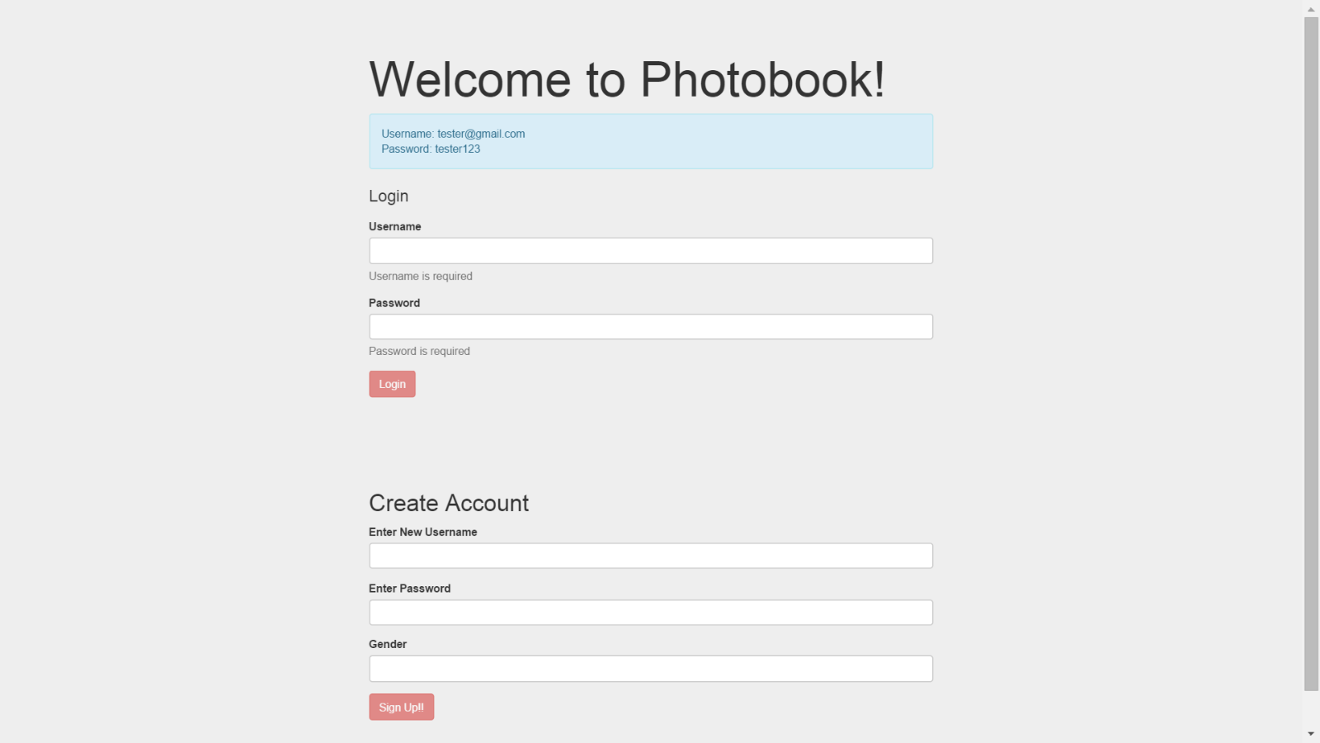

1. New account creation:
   1. Already exists
   2. 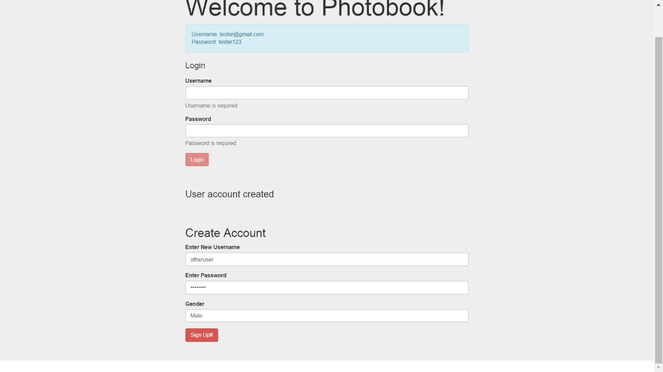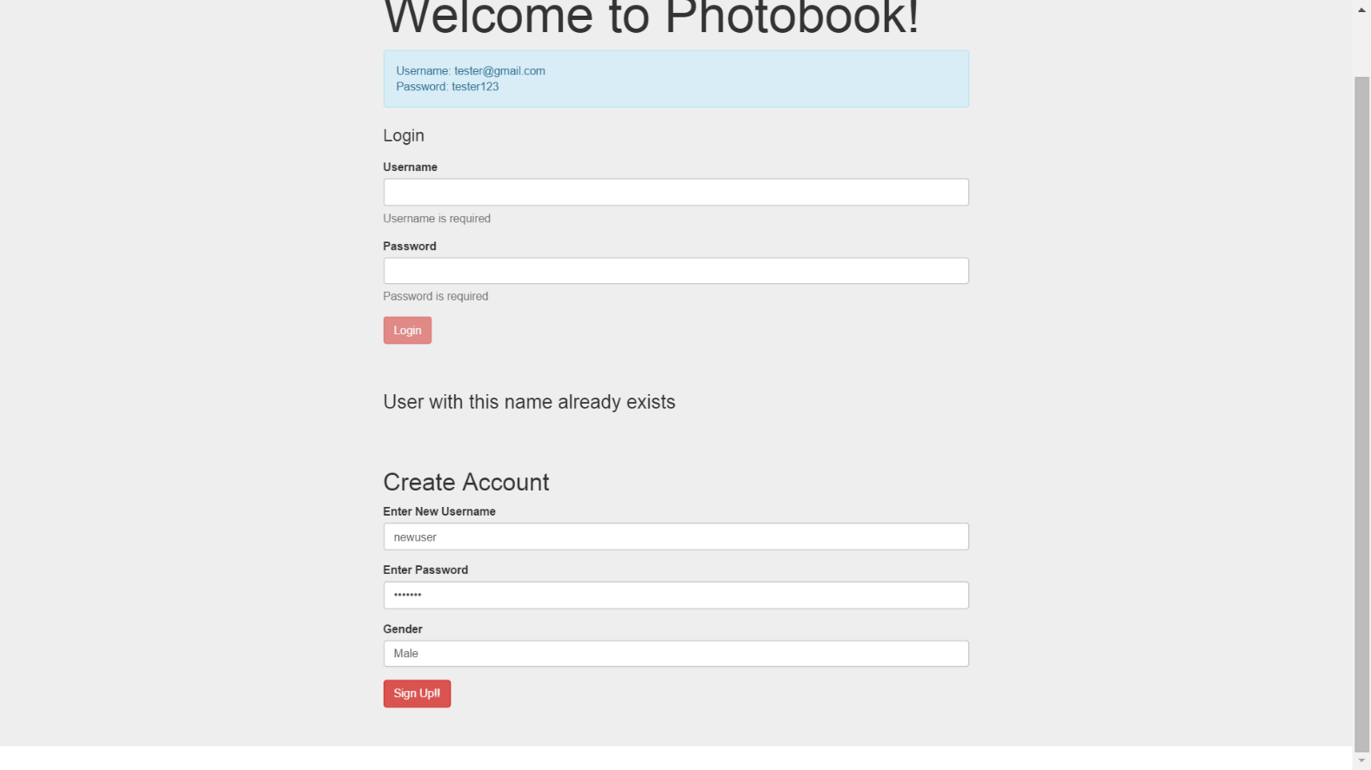Success:
2. After Sign in:
3. Click Upload Image (or Drag and drop the file in designated area) to upload and check upload image:

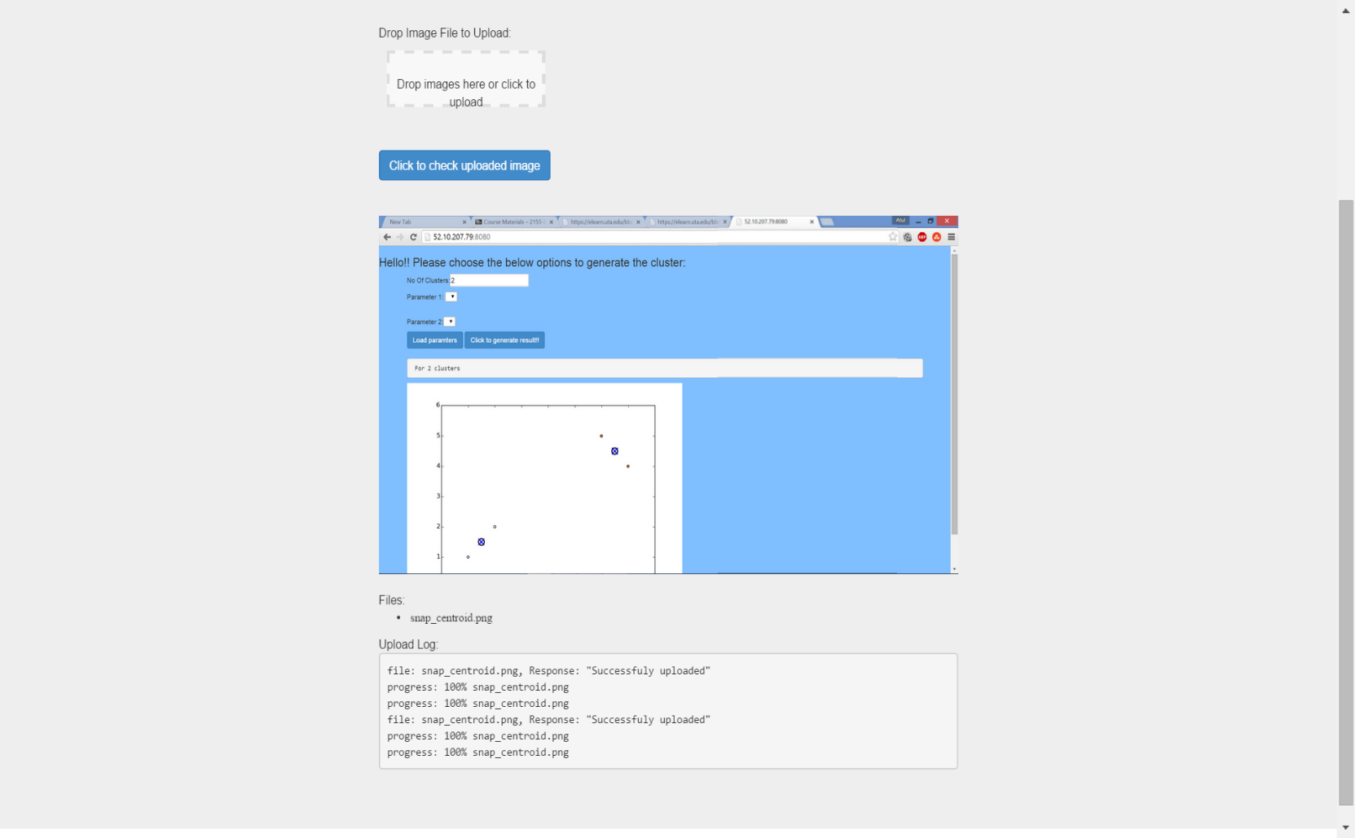

1. Display All posted images, Click My Images :

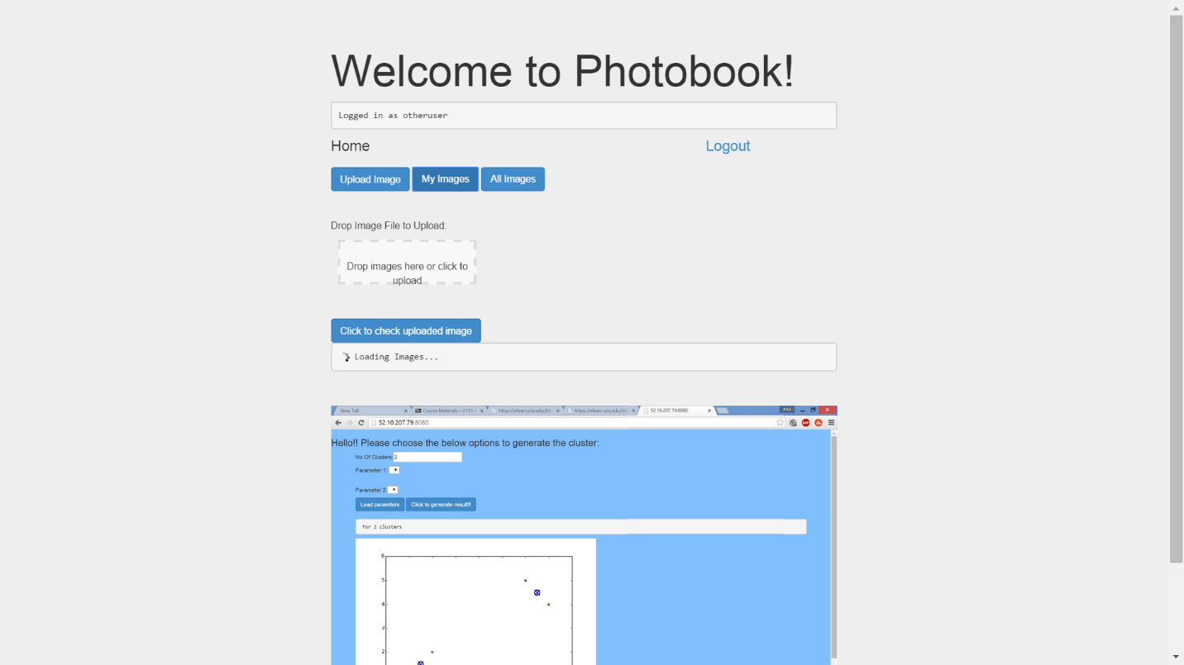

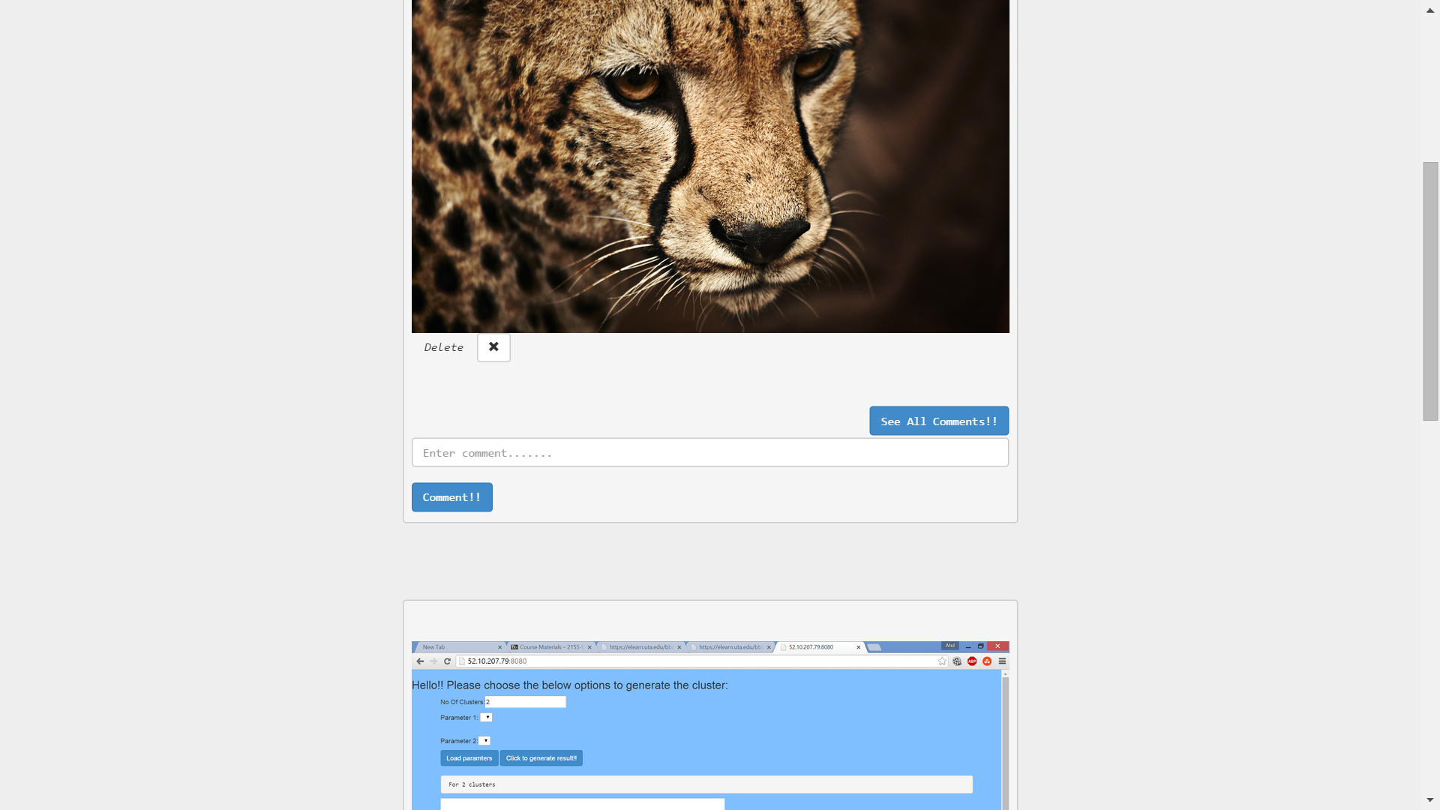

1. Comment on image:

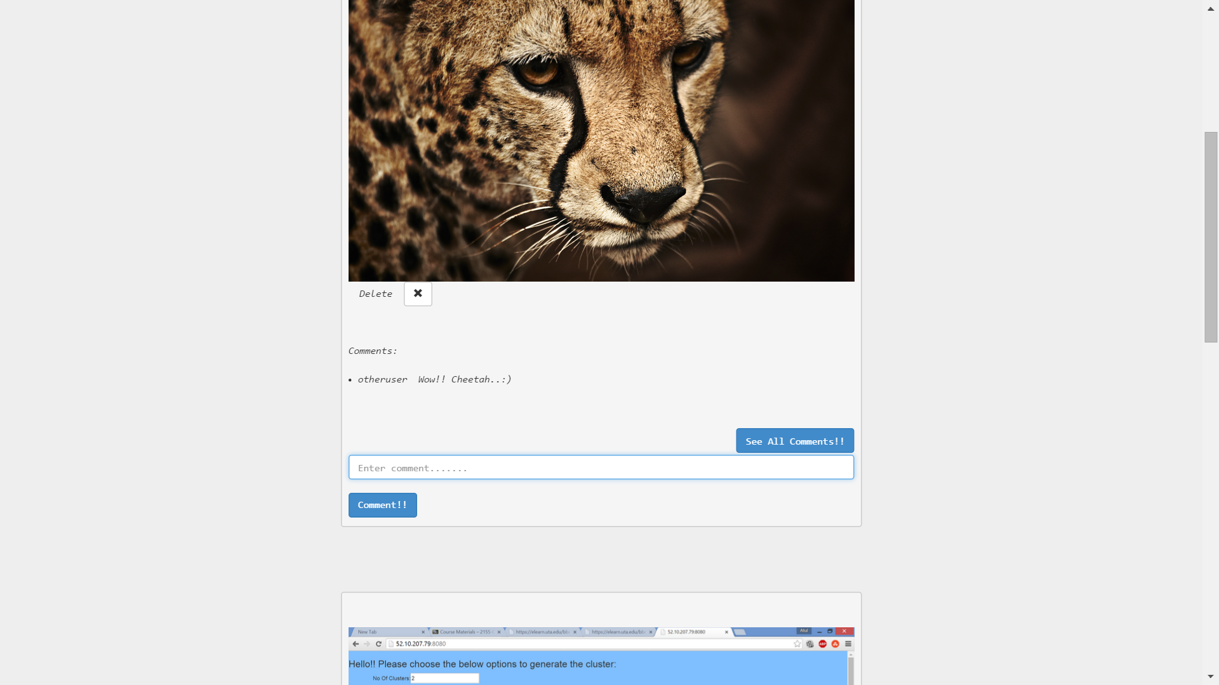

1. 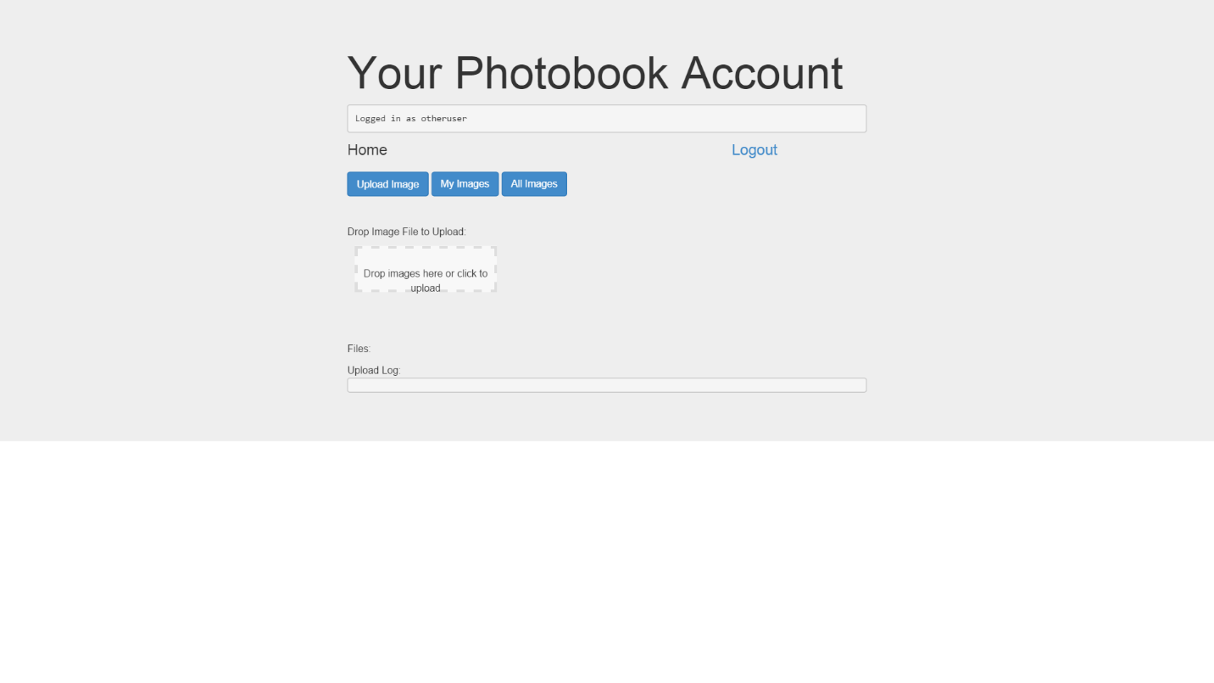Delete your uploaded image, click the Delete button ,photo is deleted from the server and it reloads the page:
2. Show All images, Click All images

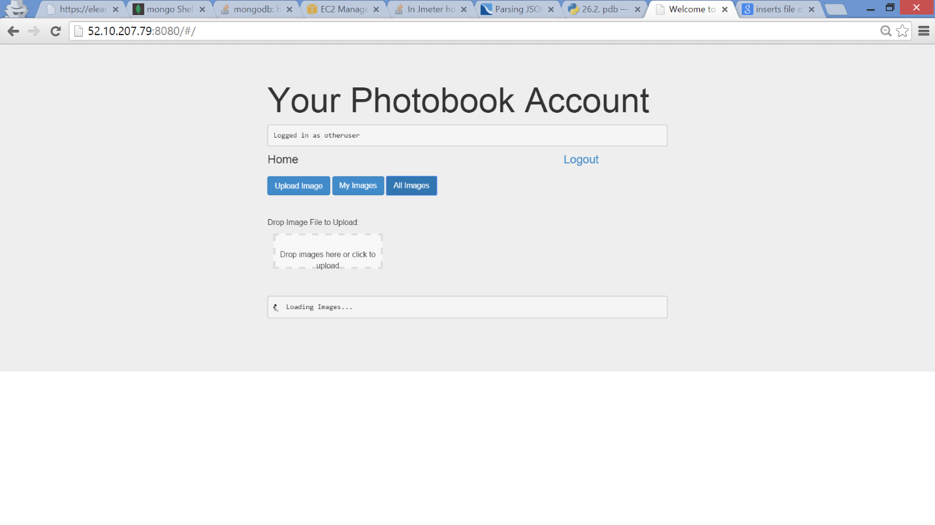

**Below are the Jmeter load testing results for each of the above features:**

***Observation***: Ran each of the operations for 50 threads (users) ,with ramp up period

Of 10s.

More number of failure response for upload picture, getAllPictures , getallmypictures, for pictures of larger size when 50 threads make request together.

Good response observed for other operations when accessed by 50 threads.

With scaling and having distributed servers the load can be distributed and overall load can be reduced with lesser response failure rate.

